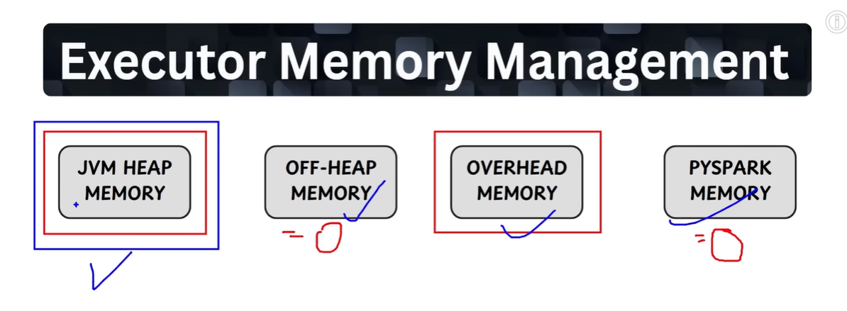

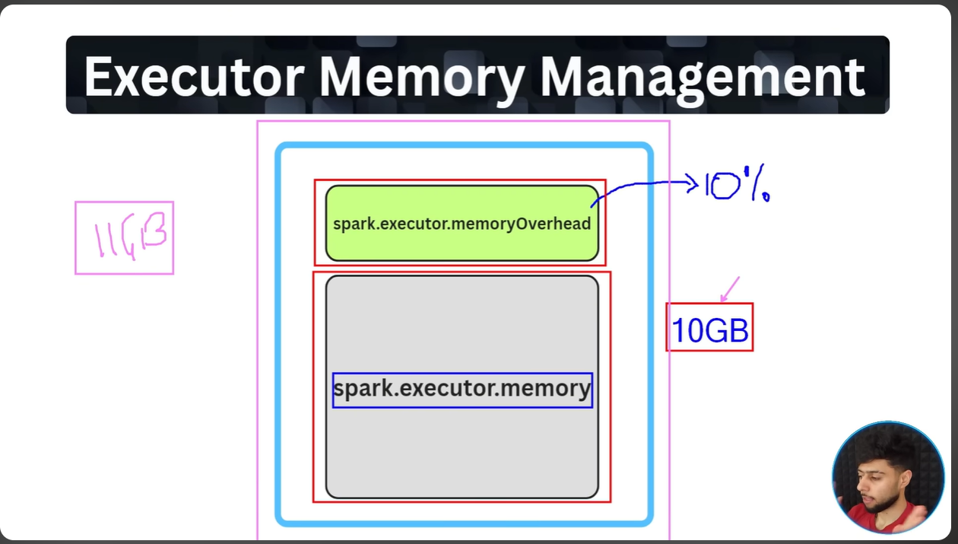

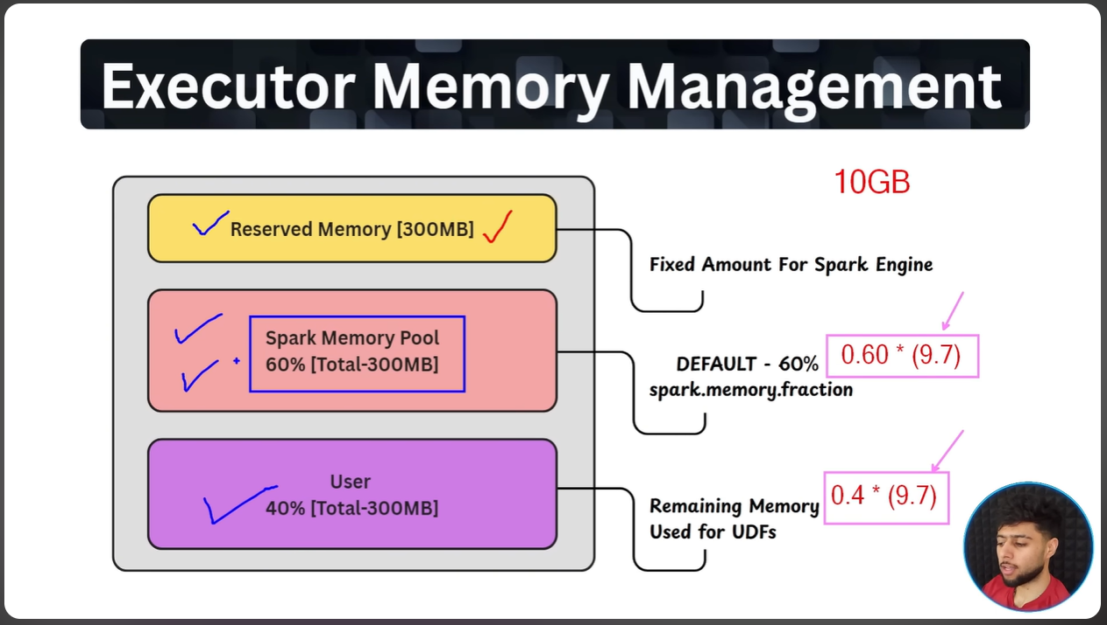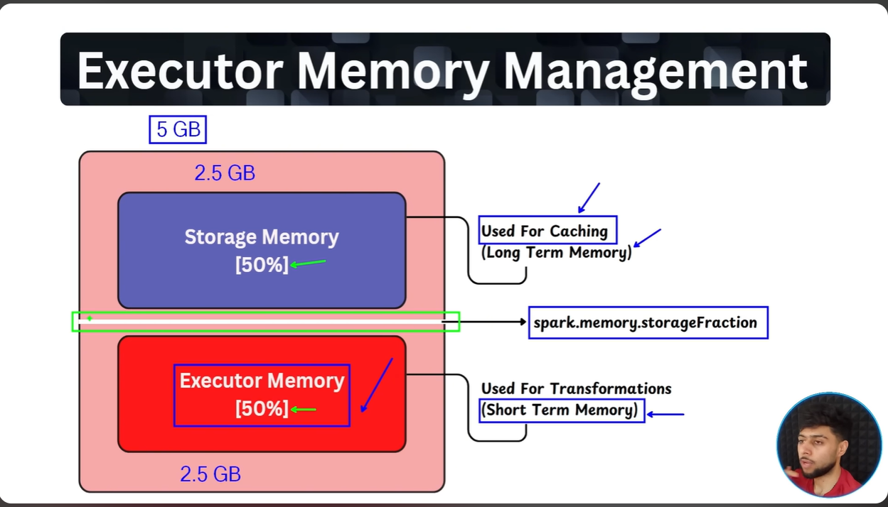
Note: This middle green line is where we define the fraction of the memory that needs to be allocated to storage and executor memory. By default, its 50 – 50 , but even if its 50-50 then also if driver found any free space it moves this green marker above and below based on memory needs for data.

